FUNCTIONAL DESIGN
Stock’N’Loan

Version 0.5




TABLE OF CONTENTS

1. Introduction 4
1.1 General 4
1.2 Purpose of this document 4
1.3 Summary 4
1.4 Reference 4
2. Application overview 5
2.1 Requirements 5
3. Process Model 7
3.1 Loan request 7
3.1.1 Request 7
3.1.2 Approve 7
3.1.3 Deny 7
3.1.4 Deliver 7
3.1.5 Exceptions 7
3.2 Return 7
3.3 Jobs process 8
3.3.1 Data consistency job 8
3.3.2 E-mail job 8
4. Dependencies 9
5. Use Cases 10
5.1 Actors 10
6. Interaction Design 11
6.1 General layout 11
6.1.1 Screen navigation 12
6.1.2 Product groups page 13
6.1.3 Product list page 14
6.1.4 Product detail page 15
6.1.5 Search page 16
6.1.6 Loans page 17
6.1.7 Shopping cart page 18
6.1.8 Feedback page 19
6.2 Look & Feel 19
6.3 Workflow 20
7. Glossary 21

Version | Date | Remarks | Author
0.1 | 4 June 2007 | Concept | M.Haring
0.5 | 5 June 2007 | Concept, additions | M. Haring

Distribution list

……….

Introduction

General
This functional design is written for the StockNLoan application to be developed. The StockNLoan application will extend the existing interface to the UTS warehouse which serves as a back office management tool. This document is based on the project description, as composed by A.H.C. Aartman and J.A. Roebert, and meetings held with A.C.H. Aartman, E Muller and M. Haring.

Purpose of this document
The purpose of this document is to give an overview of functionalities to implement in the application. Information in this document includes all functionality of the first release of the application. If certain aspects in this document refer to future releases, this should be explicitly noted.
This document also serves as a base for the technical design

Summary
Sony uses the warehousing services of UTS. As a part of the service, UTS supplies a web user interface to manage the items currently in stock. However, this interface lacks some functionality.
The items that are kept in store can be one of two kinds: Stock items and Assets. The UTS interface provides basic functionality to manage where items are stored and their quantities, but is lacks the functionality to manage items that are lend to other parties, and when they are to be returned. The application also needs the ability to mark products as assets. These items have a certain monetary value which needs to be recorded. The items also need the possibility to be blocked so no one can request them.
Next to the extended stock functionality, the application needs to implement a workflow mechanism. This would allow only users with sufficient rights to request or deliver a loan.
Finally user should be able to present new stock or assets to be stored in the warehouse.

Reference

Application overview

Requirements
The following table display a list of requirement of the application. Each requirement defines a piece of functionality to the application.

REQ no. | Description
REQ001 | Register stock items with extended properties
REQ002 | Authorize users and limit access accordingly
REQ003 | Search products
REQ004 | Notify stake holders via e-mail
REQ005 | Implement workflow
REQ006 | Report on stock
REQ007 | Request/Approve loans
REQ008 | Consistency checks

REQ001 – Register stock items with extended properties

The application at UTS keeps a simple database of the items at the warehouse. This information is fed to the StockNLoan application via import functionality. The StockNLoan application will have the ability to store more properties about an item. These properties include the following:
- Product status
- Value
- IsBlocked
- Product group
The extended properties will be stored in a separate table. This way a new import will not override the extended properties.
Preferably the import of data is done using a Web service or XML feed. This would avoid an extra user action and possible user error.

REQ002 – Authorize users and limit access accordingly

The StockNLoan application should implement a workflow to keep users from booking out items while they’re not allowed to do so. The authorization module stores information about user to the application and the access rights they have. Access rights are managed by roles. Access to a page, control or functionality is limited by roles. Users are granted access to these resources by assigning the appropriate role to the user. For better security and a better user experience, the Windows logon information is used to authenticate users. This way the user will not have to type his credentials to log into the system. Authorization works by mapping the Windows users to the roles provided by the Application. Every user who opens the application for the first time is granted a default role. With the default role: ‘Everyone’ user can only view what is in stock. They cannot place orders. To place orders the ‘Registered User’ role is needed. The third and last role to the system is the ‘Administrators’ role which allows its users the ability to assign roles to users.

REQ003 – Search products

Search functionality allows user to search for items by product name, loan requestor, loaner and end date. A search action would produce a list of products, indicating whether the product is in stock or blocked, etc. The results can be sorted.

REQ004 – Notify stake holders via e-mail

An e-mailing module will keep all relevant users up to date regarding a loan or product. The mail module will register to certain application events. When an event occurs, e.g. a loan is requested, an e-mail is generated containing information about the event and next workflow steps to undertake, if applicable. The e-mail is stored in the database. A job service will poll this database with a certain interval. The e-mail will be then sent to all users the information is relevant to. The email also contains links to the product page and, if necessary, a link to a loan contract.

REQ005 – Implement workflow

The application will incorporate a workflow system. A workflow can be defined for business processes. This way the request for a loan must follow pre-defined steps. A step can only be initiated if the previous step has been completed. To comply with the workflow the application interface can be used, as well as e-mail links. Because of the authentication model, only authorized user can follow the workflow. This will prevent contamination of the business processes. However, a backup system needs to be implemented as well so that when a user is not present to continue the workflow, his superior can take over and complete the workflow steps.

REQ006 – Report on stock

A reporting service will generate reports on the current stock in warehouse, stock lend out, blocked stock, etcetera.

REQ007 – Request loan/stock

Authorized users can browse the stock database and request a loan. This request will start the workflow. When a loan request is issued, the request is sent to the owner of the product group the product is in. The owner can then either approve of deny the request. If the request is approved, the requestor will be notified and a loan contract is generated.
A notification of the loan is also sent to the warehouse manager who is thereby approved to deliver the requested product. When delivered, the warehouse manager updates the product status and a notification of this is sent to the lender and the product group owner.

REQ008 – Consistency check

A job service will check the database giving a certain interval. During these checks the job will check if:
- E-mails should be sent
- Pending requests are cleaned up
- Pending deliveries are cleaned up
- Information regarding products is complete

Inconsistencies will be notified to the responsible user. These notifications can be taken as workflow actions to complete. This way the application enforces its users to adhere protocol.

Process Model

A successful loan request follows these steps: request, approve, and deliver. The process model describes how these steps are followed and completed and how exceptions should be handled.

Loan request

Request

A user, authorized to request a loan can browse the products available in the warehouse. Some of the products have a red marker to indicate they are currently not in stock. The user can select the product to get detailed information about the product. From this screen the user can add the product to his loan ‘basket’. This ‘shopping cart’-like system allows the user to request multiple items at the same time.
When the use is finished shopping he submits his request. Request for stock items are directly forwarded to the warehouse, no approval is needed. Asset items need additional information. For each asset the user has to provide information regarding the loan period and the location where the product is placed.

Approve

The request for the loan will be delivered to the Product Group Owner. He will then either approve or deny the request. If he approves the request the application generates a loan contract. The application will also generate an e-mail for the requestor stating the loan has been approved and can be collected. The loan contract will be attached. Lastly the application will generate an e-mail for the warehouse manager to grant him to deliver the product. The product status will be changed to ‘pending loan’.

Deny

When a loan request is denied, the warehouse manager is left out of the equation. The product manager has to state a reason of denial. The requestor is notified that his request had been denied.
The product status is reset to ‘Available’.

Deliver

When the request is approved, the warehouse manager is notified of the approval. Only then is the warehouse manager allowed to deliver a product. When a product is delivered, the warehouse manager completes the workflow. The product status is set to ‘Not available’.

Exceptions

When an exception occurs, e.g. the warehouse manager cannot locate the product, the workflow is aborted and all its participants are notified. The product status is set to ‘Unknown’.

Return

When the product is returned the warehouse manager updates the product status to ‘Returned’. The application generates an e-mail for all workflow participants stating the returning of the product. The workflow is discarded and the product status is reset to ‘Available’.

Jobs process

Data consistency job

The data consistency check job runs on a set interval. Any inconsistencies are collected and appropriate actions are taken. In most cases this means a responsible user is notified to take certain steps to make the data consistent again.

Issue | Action
Product not returned | A product is not returned while the deadline had passed. All participants in the workflow are notified. The Product Group Owner is presented with the choice to either reissue the loan, creating a new contract, or to cancel the loan.
Product not collected | A product loan is approved, but the product is not delivered. The warehouse manager is notified of this. He must provide an explanation for the product not being delivered. The product 1) is delivered but not updated 2) not yet delivered or 3) the loan had been cancelled. All users in the workflow are notified. The appropriate user should take the appropriate action
Product is pending request | While making the request, product status is set to ‘request pending’. If this is the status, but the request was initiated some time ago, the request is considered to be invalid. The status is reset to ‘Available’
Product status is ‘Available’ but a loan record exists | The product status is set to ‘Available’ but a loan record indicates it is not. The product owner is notified. This might indicate an error in the workflow.

E-mail job

The e-mail job is responsible for notifying the users. Whenever an application event is fired that requires an e-mail being sent, the e-mail is generated and added to the e-mail store. This is a table in the database holding e-mails to send. Whenever the job runs, all the e-mails, or a limited amount of e-mails are sent. When the e-mail is successfully sent, the corresponding records IsSent field is updated. When the transmission fails, the IsSent field remains false, but the NumberOfTries field is incremented. The application settings contain values indicating the e-mail throttle, the minimal amount of pending e-mails before sending, and the amount of e-mails to send at a time. This could leverage performance if resources are limited.

There are different types of e-mail the application generates. There are notifying e-mails and workflow e-mails. The notifying e-mails only role is to inform the recipient. The workflow e-mail acts as a connecting node between workflow steps. These e-mails contain links to complete the workflow step and initiate the following step. This works as follows. While the workflow e-mail is generated, a unique ID is generated which points out to the workflow and indicates the current step. When the user clicks the link, he is directed to the application. While a landing page is load, the user is authenticated, authorized and the workflow that the link refers to is load. If information is required to complete the workflow step, the user is presented with a form to supply it. Then the workflow step is set to ‘completed’, corresponding events are fired and the next step, if any, is initiated.

Dependencies

For the application to work correctly it depends on a few factors. The following table describes the dependencies and who is responsible for them

Dependency | Responsible
Complete product information | Product manager

Use Cases

The functionality of the project is described in Use Cases. The use cases will be defined using the Requirements and the Process Model.

Actors

The actors define the users of the application. These users can be actual users, but can also be other systems accessing the application.

Actor | Description
Loaner | This is the user that initiates the workflow by requesting a loan
Marketing managers | The owner of product groups. They receive loan requests and approve or deny them.
Store manager | The manager of the warehouse. Delivers the product, completes the workflow.
Job service | Running process, takes care of sending e-mail and consistency checks.

Interaction Design

This section describes how the user interacts with the system and what the screens generally look like.

General layout

Generally the page is divided in three sections: a header section, a navigation section and a content section. Both the header and navigation section will appear on every page. The actual content is displayed in the content section.

Figure 6-1 General layout

Screen navigation

The screen navigation is placed on the left side of the page. From this menu the user select what page he wants to see. Based on the roles the user has, certain items will be hidden. The elements marked green will only be seen by registered users who are permitted to place orders. The element marked red is only visible for Administrators.

Figure 6-2 Navigation

Product groups page

The product groups page display a list of available product groups. By selecting a product group the user is taken to the product list page, displaying all products in the chosen group.

Figure 6-3 Product groups page

Product list page

The product list page basically displays a list of products. This page is used through different sections of the site. Entered directly from the menu, the page displays all products found in the database. The same page is used to display search results and products in group.

Figure 6-4 Product list page

Product detail page

The product detail page displays all details about the selected product. This information includes data from the UTS backend, pictures, additional product information which was entered with this application and information regarding loan status. From this page the user can add the product to the shopping cart or.

Figure 6-5 Product detail page

Search page

The search page is used to build a search query and start the search. For each type of search the appropriate form fields are displayed. When searching by name a textbox is presented, when searching by loaner a dropdown list with names is presented. Access to certain search function could be limited to roles.

Figure 6-6 Search page

Loans page

On the loans page a user can see which loans he currently has issued and when they are due. From this page the user can proceed to the products detail page or display detail information about the loan.

Figure 6-7 Loans page

Shopping cart page

The shopping cart page is where the actual order is recorded. Here, the user can see what products he had placed in his shopping cart with the possibility to alter quantities. When submitting the order the page iterates through the selected products. When a product is an asset, additional information need be provided. For each asset this additional information is required. When all supplied information validates, the order can be processed.
Figure 6-8 Shopping cart

Feedback page

The feedback page is used to inform the user if an error had occurred, or to provide additional information.

Figure 6-9 Feedback page

Look & Feel

The general look and feel of the application will look as follows:

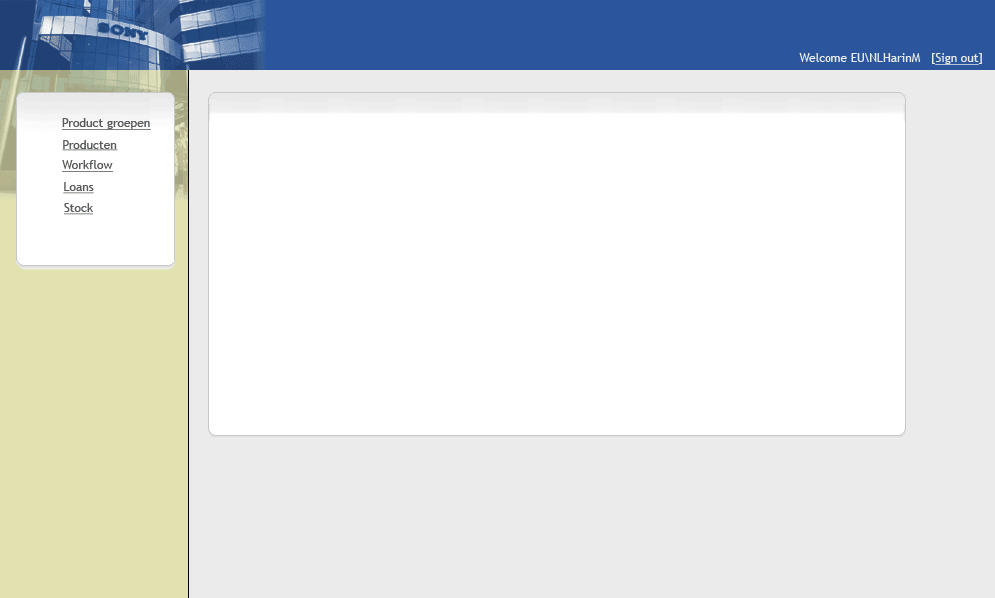
Figure 6-10 Look & Feel

Workflow

The following diagram displays the workflow of an order of stock or asset.

Figure 6-11 Workflow

Glossary

Warehouse | Any store to house stock or assets. Currently 3 warehouses are defined: UTS, warehouse and showroom

